**

SCHOOL OF ELECTRICAL AND ELECTRONIC ENGINEERING

Bachelor of Engineering (Hons) BE in Elect/Cont/Comm/Comp Eng

Program Code: (DT021A)

<YEAR 4>

Name of Module: ([Thermodynamics, ENER4601](https://brightspace.tudublin.ie/d2l/home/179100))

**TU Dublin – Grangegorman**

**Marcet Boiler Rig Experiment**

Student Name: _Talha Tallat, D18124645 ______________

Academic Lecturer:  _John McGrory___________________ _

Submission Date: _17th December 2021___________________

Table of Contents

1. Experiment Aim 3

1.1. Experiment Objectives 3

2. Introduction 4

2.1. Equipment & components 4

3. Procedure 5

3.1. Test 1 6

3.1.1. Evaporator Pressure 7

3.1.2. Condenser Pressure 7

3.1.3. Evaporator Cofficient performance 7

3.1.4. Condenser Cofficient performance 8

3.2. Test 2 9

3.2.1. Evaporator Pressure 10

3.2.2. Condenser Pressure 10

3.2.3. Evaporator Cofficient performance 10

3.2.4. Condenser Cofficient performance 10

3.3. Test 3 12

3.3.1. Evaporator Pressure 13

3.3.2. Condenser Pressure 13

3.3.3. Evaporator Cofficient performance 13

3.3.4. Condenser Cofficient performance 13

3.4. Experiment Question 14

4. Conclusion 15

5. References 15

Table of Figures

Figure 1 - Enthalpie graph of refrigeration rig experiment test 1[1] 5

Figure 2 - Enthalpie graph of refrigeration rig experiment test 2 [1] 8

Figure 3 - Enthalpie graph of refrigeration rig experiment test 3 [1] 11

List of Table

Table 1 - Assigned Experiment data #3 4

# Experiment Aim

This experiment aims to demonstrate the thermodynamic basic principle of vapour pressure and temperature during a phase change.

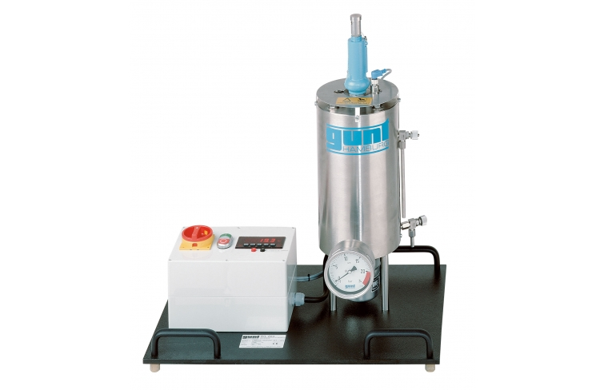

Figure 1 - Marcet Boiler [1]

## Experiment Objectives

1. This video describes the operation of the whole rig and all its parts. It explains the evaporation of vapour from water and the condensation back to the water when it cannot escape from the chamber. The relationship between pressure and temperature in a phase change is discussed.

3. Your submission:

b) Complete the calculations for your Experiment Data #. Clearly show your work, calculations, steps and graphs used. The usual formality of the laboratory report is not necessary for the video experiments.

c) compare your results about the steam tables value and clarify if the results were comparable. Were there any parts of the results that did not match the steam table calculated values? If there were, can you explain what has occurred?

d) Answer the following questions:

a. Entropy (s) is a partial derivative with both DV and dT terms. But in this particular experiment, some magic occurs that allows us to manage entropy (s) as a full derivative of DV? Explain what the magic is.

b. Steam can transfer six times the amount of energy when compared to the same bore (Diameter) of pipe containing water. It’s used for heating buildings, chemical processes and power generation. But if we are to keep using it we need to eliminate our need on fossil fuels to produce it. Explain a process on how steam could be produced commercially without using any fossil fuels?

c. In the calculations we use the “Latent Heat” of steam. Explain the difference between latent heat and sensible heat and why did we use latent heat in our calculations.

# Introduction

Marcet boiler is defined to express the thermodynamic basic principle of a boiling phenomenon. It signifies the fundamental pressure-temperature relationship of saturated steam in equilibrium with the water. This experiment covers the Marcet boiler, which is used to calculate the relation between pressure and temperature of saturated steam. We look at the relationship between vapour pressure and temperature during a phase change.

The water inside the boiler is heated by the electrical resistance and starts to evaporate. When more water changes phase from liquid to vapour more vapour accumulates inside the boiler vessel and increases the pressure imposed on the water surface. The build-up pressure tends to increase the resistance faced by liquid molecules as they change into a vapour consequently increasing the saturation temperature of the remaining liquid.

## 2.1. Equipment & components

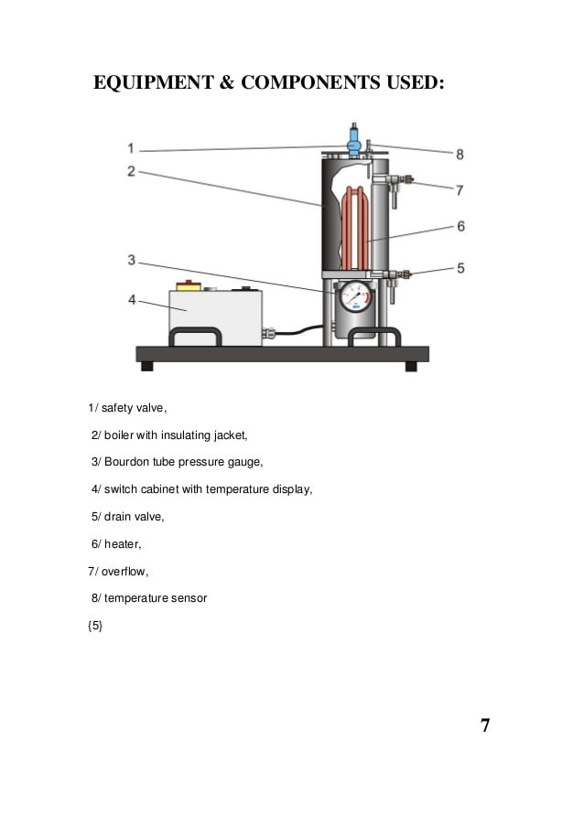

Figure 2 - Scenatic of Marcet Boiler Experiment [2]

1. Safety valve
2. Boiler with an insulating jacket
3. Bourdon tube pressure gauge
4. Switch cabinet with temperature display
5. Drain valve
6. Heater
7. Overflow
8. Temperature sensor

# Procedure

Table 1 - Assigned Experiment data #3

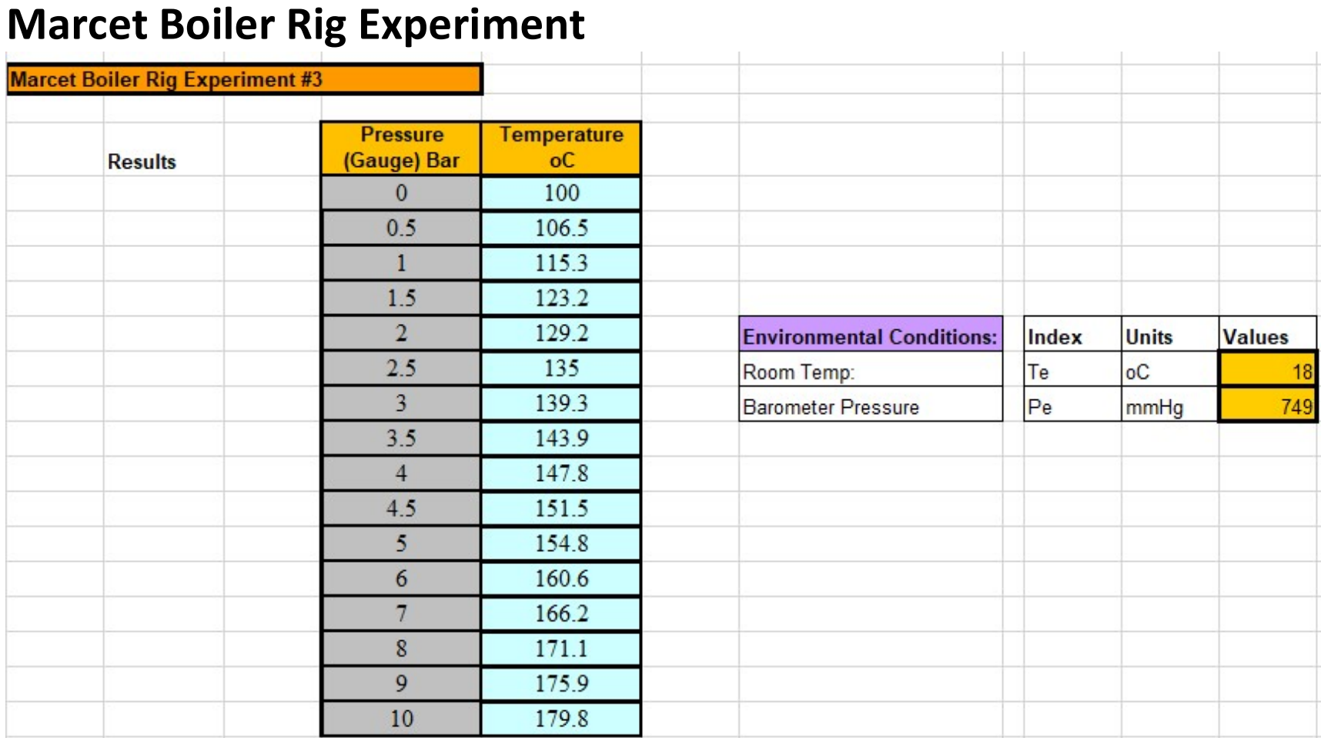

## 3.1. Test 1

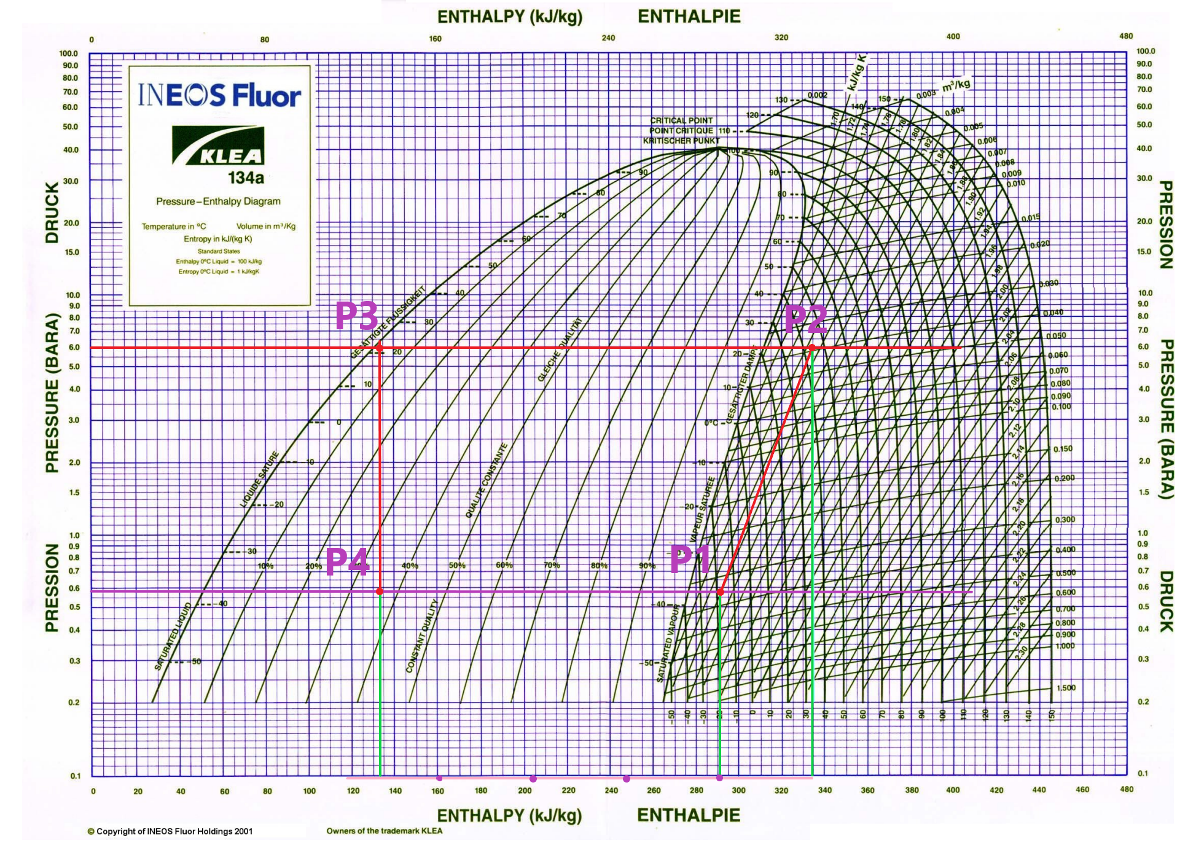

Figure 3 - Enthalpie graph of refrigeration rig experiment test 1[1]

3.1.1. Evaporator Pressure

Taking the Evagaugeor pressure t the guage is $-42 KN/m^{2}$ and coverting it to bar where bar is the unit of pressure.

$$1 bar= 1 ×{10}^{5}N/m^{2}$$

$$1KN/m^{2}= 1 ×{10}^{3}N/m^{2}$$

So we can divide by 100 in order to covert $KN/m^{2}$ to bar.

$$\frac{-42 KN/m^{2} }{100}=-0.42 bar Gauge pressure$$

However, finding the abslout pressure, since we are above certain see level therefore, taking in count of a constant atmospheric pressure which is 1 bar.

$$abslout pressure= Gauge pressure+atmospheric pressure$$

$$-0.42+1=0.58 bar ABS Pressure$$

3.1.2. Condenser Pressure

Taking the Condenser pressure at the guage is $500 KN/m^{2}$ and coverting it to bar.

$$\frac{500 KN/m^{2} }{100}=5 bar$$

$$abslout pressure= Gauge pressure+atmospheric pressure$$

$$5+1=6 bar ABS Pressure$$

3.1.3. Evaporator Cofficient performance

Cofficient performance of the evaporator is evaportaotor rate deividided by the compracer energy put in.

$${COP}_{E}=\frac{h_{1}- h_{4}}{h_{2}- h_{1}}$$

Enthalpy values are taken from the graph in figure 1, which are:

$$h_{3}=h_{4}≈133.5 kj/kg$$

$$h_{1}≈291 kj/kg$$

$$h_{2}≈335 kj/kg$$

$${COP}_{E}=\frac{291- 133.5}{335- 291}=3.58$$

3.1.4. Condenser Cofficient performance

The Cofficient performance of the condenser is usually one more than the evaporator coefficient performance. We can calculate to find it.

$${COP}_{C}=\frac{h_{2}- h_{3}}{h_{2}- h_{1}}$$

$${COP}_{E}=\frac{335- 133.5}{335- 291}=4.58$$

The output of Cofficient performance of the condenser calculats to be 3.58 where the evaporator coefficient performance is 4.58 which is 1 higher as expected.

## 3.2. Test 2

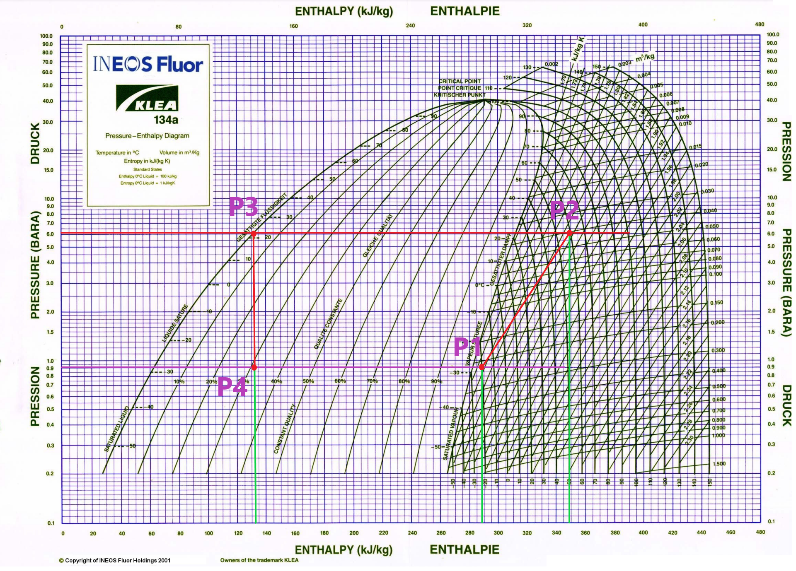

Figure 4 - Enthalpie graph of refrigeration rig experiment test 2 [1]

3.2.1. Evaporator Pressure

In test 2, taking the Evaporator pressure at the guage is $-10 KN/m^{2}$ and coverting it to bar where bar is the unit of pressure.

So we can divide by 100 in order to covert $KN/m^{2}$ to bar.

$$\frac{-10 KN/m^{2} }{100}=-0.1 bar Gauge pressure$$

$$abslout pressure= Gauge pressure+atmospheric pressure$$

$$-0.1+1=0.9 bar ABS Pressure$$

3.2.2. Condenser Pressure

In test 2, taking the Condenser pressure at the guage is $510 KN/m^{2}$ and coverting it to bar.

$$\frac{510 KN/m^{2} }{100}=5.1 bar$$

$$abslout pressure= Gauge pressure+atmospheric pressure$$

$$5.1+1=6.1 bar ABS Pressure$$

3.2.3. Evaporator Cofficient performance

Cofficient performance of the evaporator is evaportaotor rate deividided by the compracer energy put in.

$${COP}_{E}=\frac{h_{1}- h_{4}}{h_{2}- h_{1}}$$

In test 2, Enthalpy values are taken from the graph in figure 2, which are:

$$h_{3}=h_{4}≈132.5 kj/kg$$

$$h_{1}≈288.5 kj/kg$$

$$h_{2}≈348.5 kj/kg$$

Cofficient performance of the evaporator:

$${COP}_{E}=\frac{288.5- 132.5}{348.5- 288.5}=2.6$$

3.2.4. Condenser Cofficient performance

In test 2, the Cofficient performance of the condenser is usually one more than the evaporator coefficient performance. We can calculate to find it.

$${COP}_{C}=\frac{h_{2}- h_{3}}{h_{2}- h_{1}}$$

$${COP}_{E}=\frac{348.5 - 132.5}{348.5 - 288.5}=3.6$$

The output of Cofficient performance of the condenser calculats to be 2.6 where the evaporator coefficient performance is 3.6 which is 1 more greater as expected.

## 3.3. Test 3

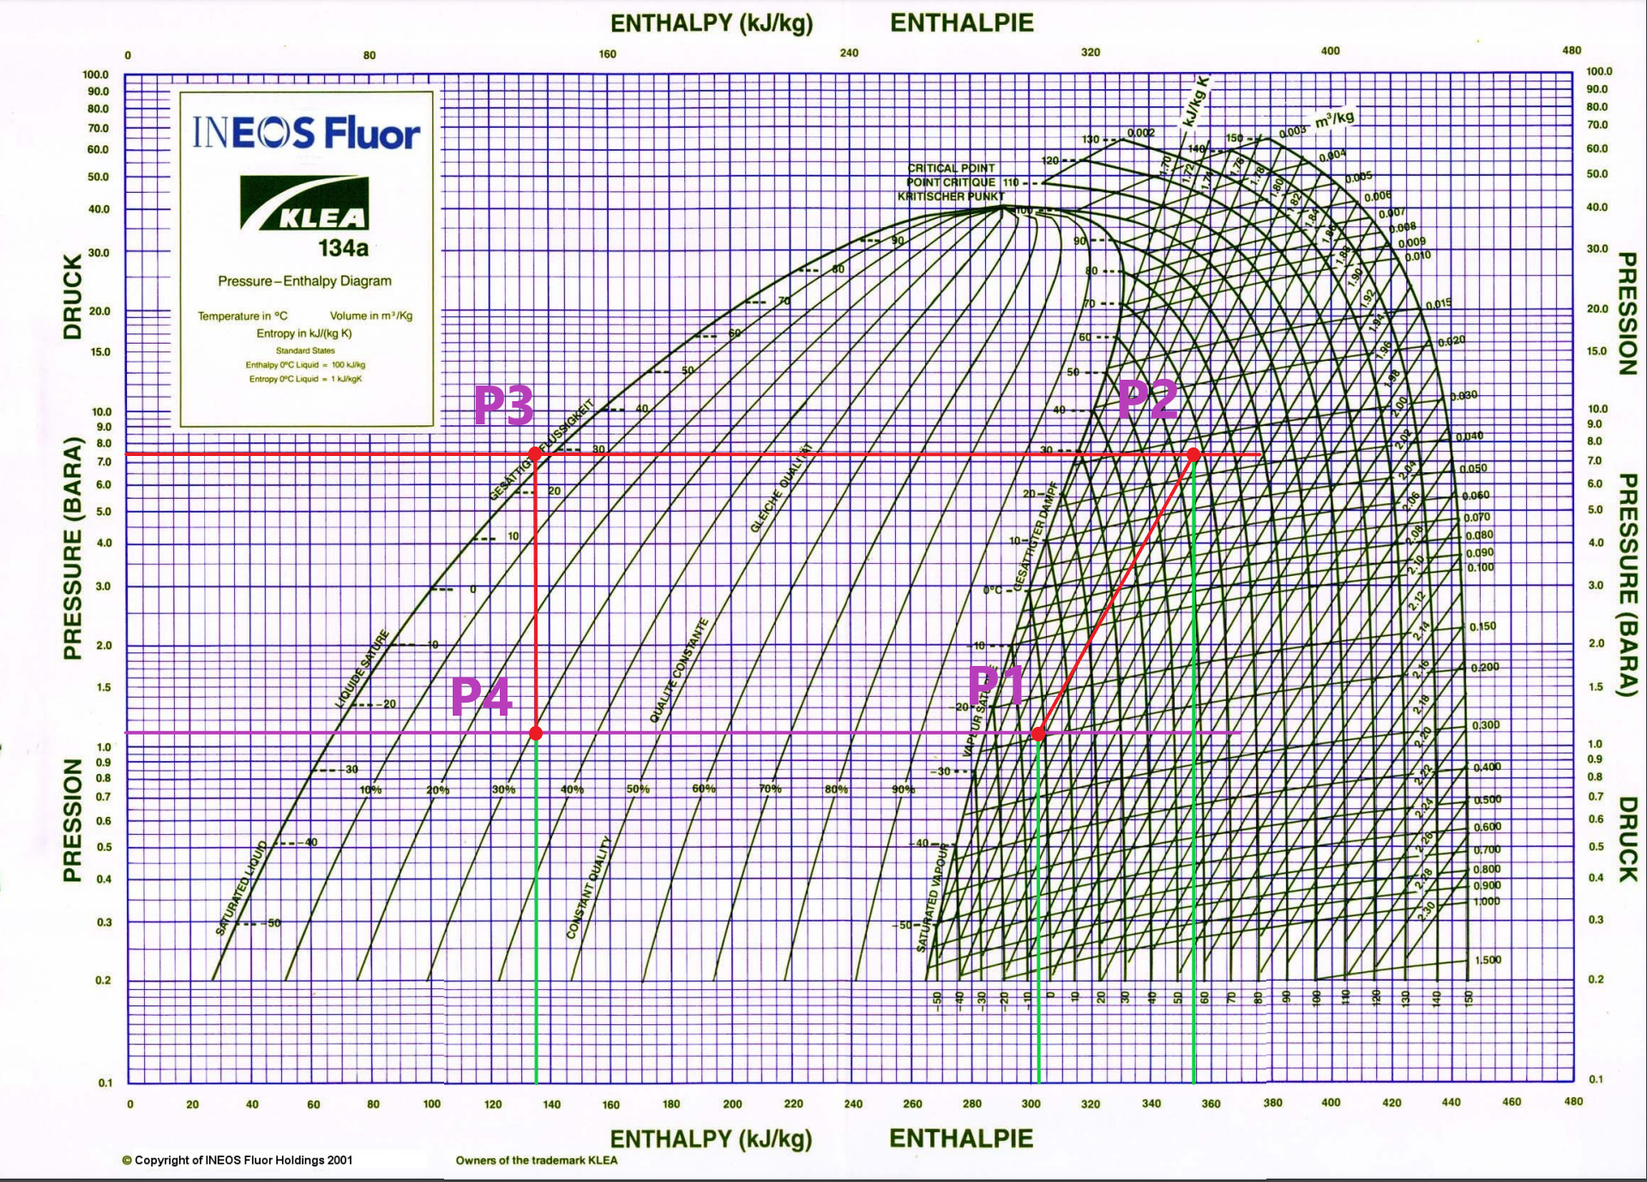

Figure 5 - Enthalpie graph of refrigeration rig experiment test 3 [1]

3.3.1. Evaporator Pressure

In test 3, taking the Evaporator pressure at the guage is $10 KN/m^{2}$ and coverting it to bar where bar is the unit of pressure.

So we can divide by 100 in order to covert $KN/m^{2}$ to bar.

$$\frac{10 KN/m^{2} }{100}=0.1 bar Gauge pressure$$

$$abslout pressure= Gauge pressure+atmospheric pressure$$

$$0.1+1=1.1 bar ABS Pressure$$

3.3.2. Condenser Pressure

In test 3, taking the Condenser pressure at the guage is $640 KN/m^{2}$ and coverting it to bar.

$$\frac{640 KN/m^{2} }{100}=6.4 bar$$

$$abslout pressure= Gauge pressure+atmospheric pressure$$

$$6.4+1=7.4 bar ABS Pressure$$

3.3.3. Evaporator Cofficient performance

Cofficient performance of the evaporator is evaportaotor rate deividided by the compracer energy put in.

$${COP}_{E}=\frac{h_{1}- h_{4}}{h_{2}- h_{1}}$$

In test 3, Enthalpy values are taken from the graph in figure 1, which are:

$$h_{3}=h_{4}≈135 kj/kg$$

$$h_{1}≈302.5 kj/kg$$

$$h_{2}≈358.5 kj/kg$$

$${COP}_{E}=\frac{302.5- 135}{358.5- 302.5}=3$$

3.3.4. Condenser Cofficient performance

The Cofficient performance of the condenser is usually one more than the evaporator coefficient performance. We can calculate to find it.

$${COP}_{C}=\frac{h_{2}- h_{3}}{h_{2}- h_{1}}$$

$${COP}_{E}=\frac{358.5- 135}{358.5- 302.5}=4$$

The output Cofficient performance of the condenser calculats to be 3 where the evaporator coefficient performance is 4 which is 1 higher as expected.

## 3.4. Experiment Question

Dry bulb temperature (T1) of air entering base of the column and Wet bulb temperature (T2) of air entering the base of a column.

Dry bulb temperature (T3) of air at the exit from a column and Wet bulb temperature (T4) of air at the exit from the column.

T1 is hotter than T3, since we are dissipating energy the outlet air temperature T3 should be hotter than the inlet air temperature T1! it may seem unusual, however, the idea of evaporating cooling is where an object that is damped evaporates moisture and its colder than the environment that is its in.

# 4. Conclusion

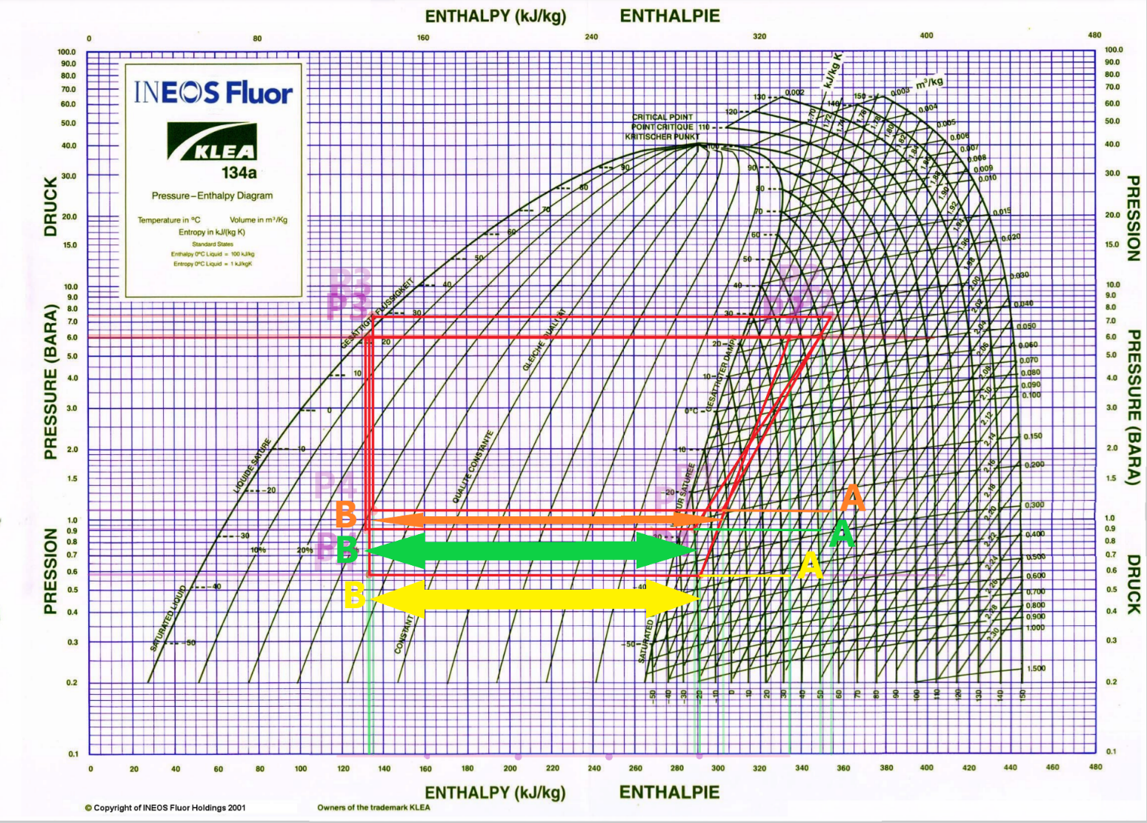

After carrying out the test 2 we notice that the angle changed then it has an effect on the coefficient.  
  
Energy balance:

# 5. References

**[1]** "Products", *Gunt.de*, 2021. [Online]. Available: https://www.gunt.de/en/products/thermal-engineering/fundamentals-of-thermodynamics/phase-transition/vapour-pressure-of-water-marcet-boiler/060.20400/wl204/glct-1:pa-148:ca-92:pr-1469. [Accessed: 10- Dec- 2021]

**[2]** A. Tahir, "marcet boiler", *Pt.slideshare.net*, 2021. [Online]. Available: https://pt.slideshare.net/areesalah/marcet-boiler-30868236. [Accessed: 10- Dec- 2021]